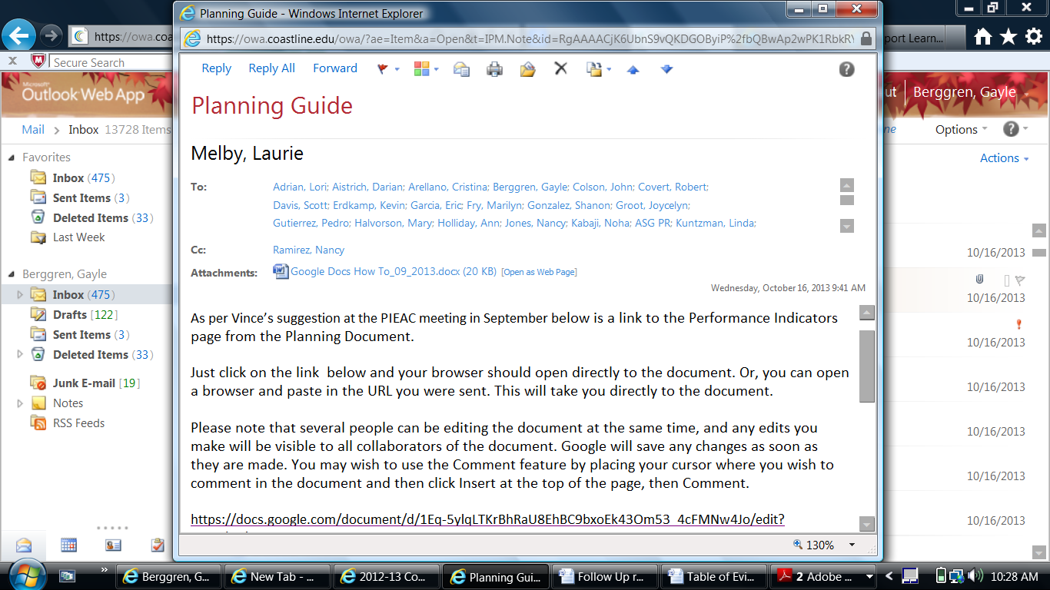

- - - - - - - - - - - -
Follow-up email from Researcher, Jorge Sanchez on October 16, 2013:

To clarify a bit:
The Key Performance Indicators outlined in this [Google] document are the same indicators in our College Scorecard.

Those KPIs have been discussed widely, are known, and significant progress has been made in producing the Scorecard.

What we don’t have are specific activities i.e. strategic initiatives that support and align with this KPIs.

Please provide Strategic Initiatives (activities) that support our college goals.
Ideally, these activities produce the desired outcomes as measured by our KPIs.
Hopefully we can get your input by the time PIEAC meets again on October 30, 2013.
Jorge

